Notice for Successful Candidates in 2020 Spring Semester
(Graduate school in Ajou University)

Congratulations for your admission!
This is important information for you, please read it carefully.
Academic information for graduate school students will be noticed again around first week of February, 2020

1. Visa documents
- certificate of admission, certificate of scholarship, invitation letter, tuition bill(We will send the tuition bill to you by email individually)
- International students who live abroad : We will send them to you.
- International students who live in Korea : After paying tuition fees within registration period, You need to visit graduate school office and take the documents for changing or extending visa status. ( #305 Yulgok Hall, Please contact us before visiting our Office to check that your documents are prepared.)

**Please contact the Korean embassy in your country, local immigration office or HiKorea(02-1345) for the required documents as the required documents may differ depending on the region.

※All visa related affairs are solely upon individual responsibility of the student. The school office offers limited service and is not responsible for any visa matter that may occur.
★ E-Governent for Foreigners: www.hikorea.go.kr , telephone: 02-1345 (offers multi language services)

2. Registration
You can print out the tuition bill on our website ( http://e-grad.ajou.ac.kr )
a. period : From January 6th(Mon) ~ January 17th(Fri), 2020
b. Payment Place : KB Bank
- If you cannot pay tuition during this period, your admission will be cancelled.
- Those who cannot pay during the period given above due to the residential status- staying abroad at the time of registration period, please contact us in advance and those student should submit the Postponing Document until December 27th, 2019.
※ If a student applied for a refund of the tuition fee, the paid admission fee cannot be refunded and the tuition fee will also be refunded according to the date of applying for the refund.
c. Tuition Fee (Korean Won, Academic year 2019, may change for the year 2020)
Department | Admission Fee | Tuition Fee | Sum
Engineering | 900,000 | 6,026,000 | 6,926,000
Natural Sciences | 900,000 | 5,208,000 | 6,108,000
Humanity/Social Sciences | 900,000 | 4,530,000 | 5,430,000
Financial Engineering | 900,000 | 5,681,000 | 6,581,000
Pharmacy | 900,000 | 6,524,000 | 7,424,000
Medical Science | 900,000 | 7,022,000 | 7,922,000

※ How to print the tuition bill
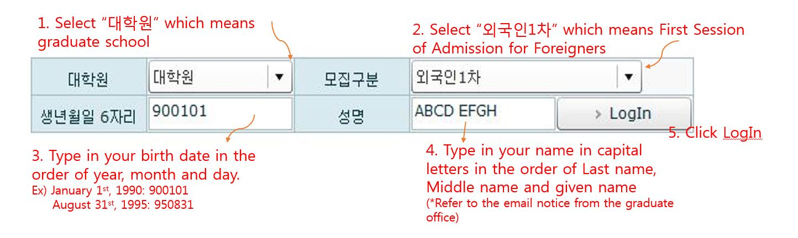
※ How to read the tuition bill
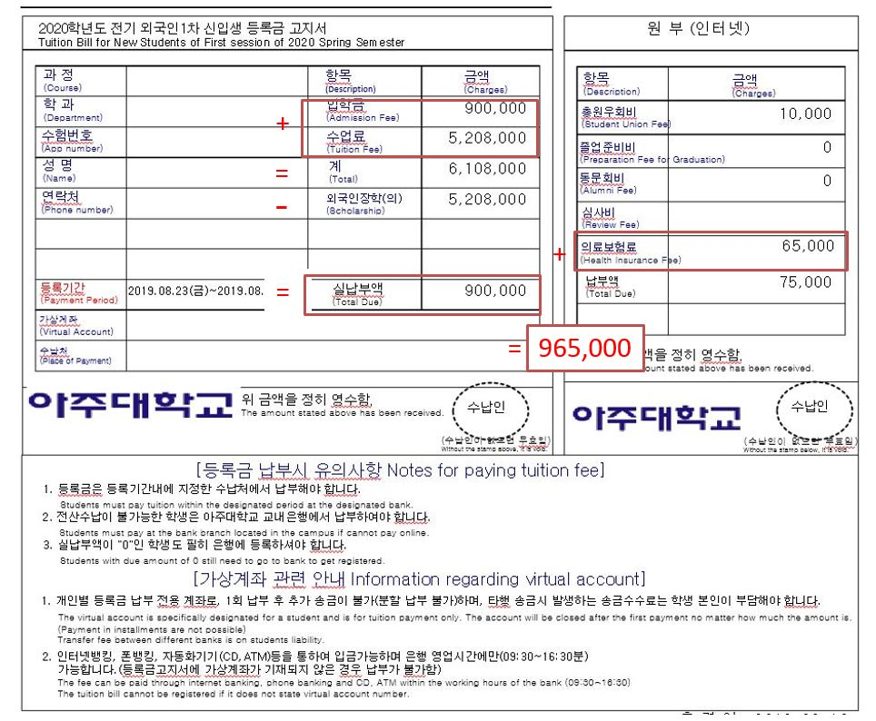

3. Scholarship
- Your scholarship information is on the tuition bill.
- To be granted Scholarship continuously, students should take at least 4 credits and maintain a GPA of 3.5 or higher without F in each semester (Masters: up to 4 semesters, Doctoral : up to 6 semesters, Integrated program : up to 8 semesters)
- Scholarship will be available only for the students before completion of credits
- Scholarship will be cancelled if the students applied for the leave of absence.

4. Application for classes
a. Period : around early February then again in March for changing and application for the classes.
b. How to apply: Application process will be noticed on graduate school website.(grad-e.ajou.ac.kr)
※You can get information about classes from the coordinator in each department office.

5. Commencement of Spring Semester 2020
: March. 2nd (Mon), 2020

6. Student ID number
- After registration period, the student ID number will be announced on graduate school website and also through email around early February, 2020.
- With your student ID number, you must create an account on AIMS portal. https://mportal.ajou.ac.kr
- Instruction on how to make an account will be noticed through email later on.

7. Student ID card.
- You can get your student ID card in late February from the graduate school office and for that you have to agree to a consent of using private information on AIMS.
- And we will notice it again. (http://grad-e.ajou.ac.kr)

8. Orientation for International students in 2020 Spring semester.
- Around late February, 2020
- The schedule will be noticed later. (http://grad-e.ajou.ac.kr)

9. Dormitory
- The dormitory office will notice dormitory application information on the notice board around late December to early January ▷http://edorm.ajou.ac.kr
- Each student must apply themselves online by going to the dorm website http://edorm.ajou.ac.kr and clicking [New Graduates] circled in red in the image below.

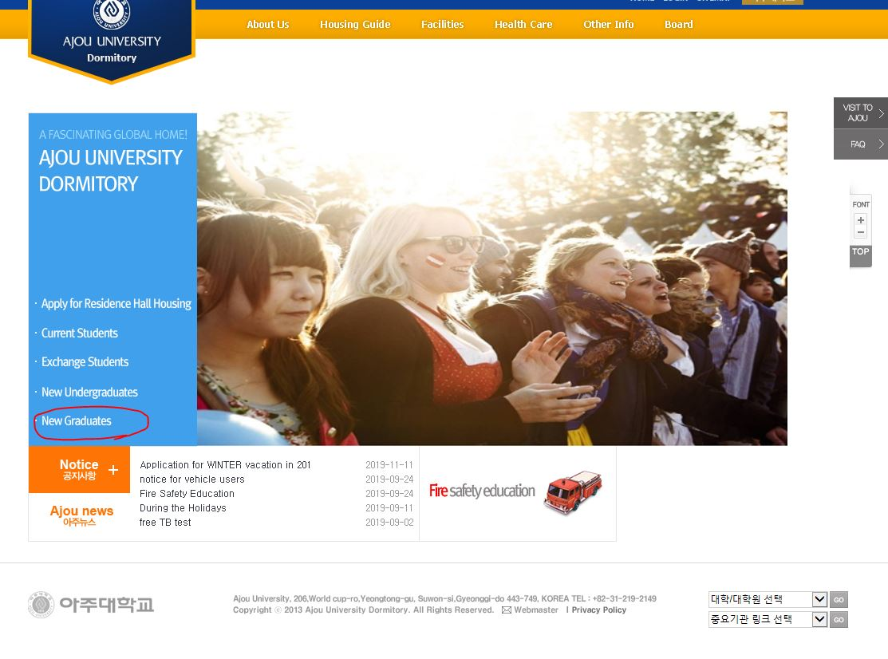
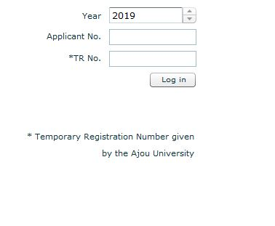
Then select the year to 2020, type in your applicant number and TR number that the graduate school office let you know. (Applicant number: 21A~~~~, TR number: date of birth-1111111/ 222222)
- If you delay paying dormitory fee, your assigned room may be cancelled and get re-assigned to another student. Please consider getting a place outside the campus if you cannot pay dormitory fee in time due to late arrival in Korea.
- Any questions regarding the dormitory, please contact the dormitory coordinator jhk1092@ajou.ac.kr

10. Contact information of Graduate School Office
If you have any questions, please contact us.
- Address: Office of Graduate School Room 305 Yulgok Hall, Ajou University, World cup-ro 206, Yeongtong-gu, Suwon-si, Gyeonggi-do, Korea. Postal code: 16499 (Office Hours: 09-18, Weekdays, lunch break:12-13)
- Email : grad@ajou.ac.kr

11. Pre-arrival Information. - We will notice pre-arrival information later.
12. Contact number for each department office (Some of the staff may not speak English)

Department Office | Telephone | Department Office | Telephone
Civil Systems Engineering | 031-219-1534 | Mathematics | 031-219-2553
Architectural Engineering | 031-219-1530 | System Engineering | 031-219-3579
Architecture | 031-219-1530 | Pharmacy | 031-219-3432
Management Information Systems | 031-219-2705 | Energy Systems Research | 031-219-2207
Business Administration | 031-219-2705 | English Language and Literature | 031-219-2802
Military Digital Convergence | 031-219-2990 | Applied Social Science | 031-219-2736
Korean Language and Literature | 031-219-2802 | Applied Biotechnology | 031-219-3579
Financial Engineering | 031-219-3661 | AI and Data Science | 031-219-3897
Mechanical Engineering | 031-219-2336 | Biomedical Engineering | 031-219-3579
Digital Humanities & Convergence | 031-219-2802 | Medical Sciences, Biomedical Sciences | 031-219-4527
Life Media | 031-219-3646 | Electrical and Computer Engineering | 031-219-1877
Culture and Contents | 031-219-2802 | Political Science and Diplomacy | 031-219-2736
Physics | 031-219-2553 | Computer Engineering | 031-219-2645
Law | 031-219-3779 | Public Administration | 031-219-2732
Molecular Science & Technology | 031-219-1593 | Chemical Engineering | 031-219-2381
Industrial Engineering | 031-219-2416 | Chemistry | 031-219-2553
Biological Science | 031-219-2553

